(6a) A program that accepts the following data about one customer’s messages: area code (three digits), phone number (seven digits), and number of text messages sent. Display all the data, including the month-end bill both before and after taxes are added.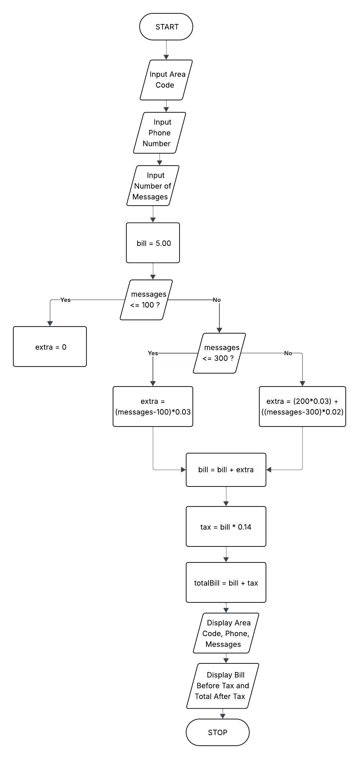
(6b) A program that continually accepts data about text messages until a sentinel value is and displays all the details entered..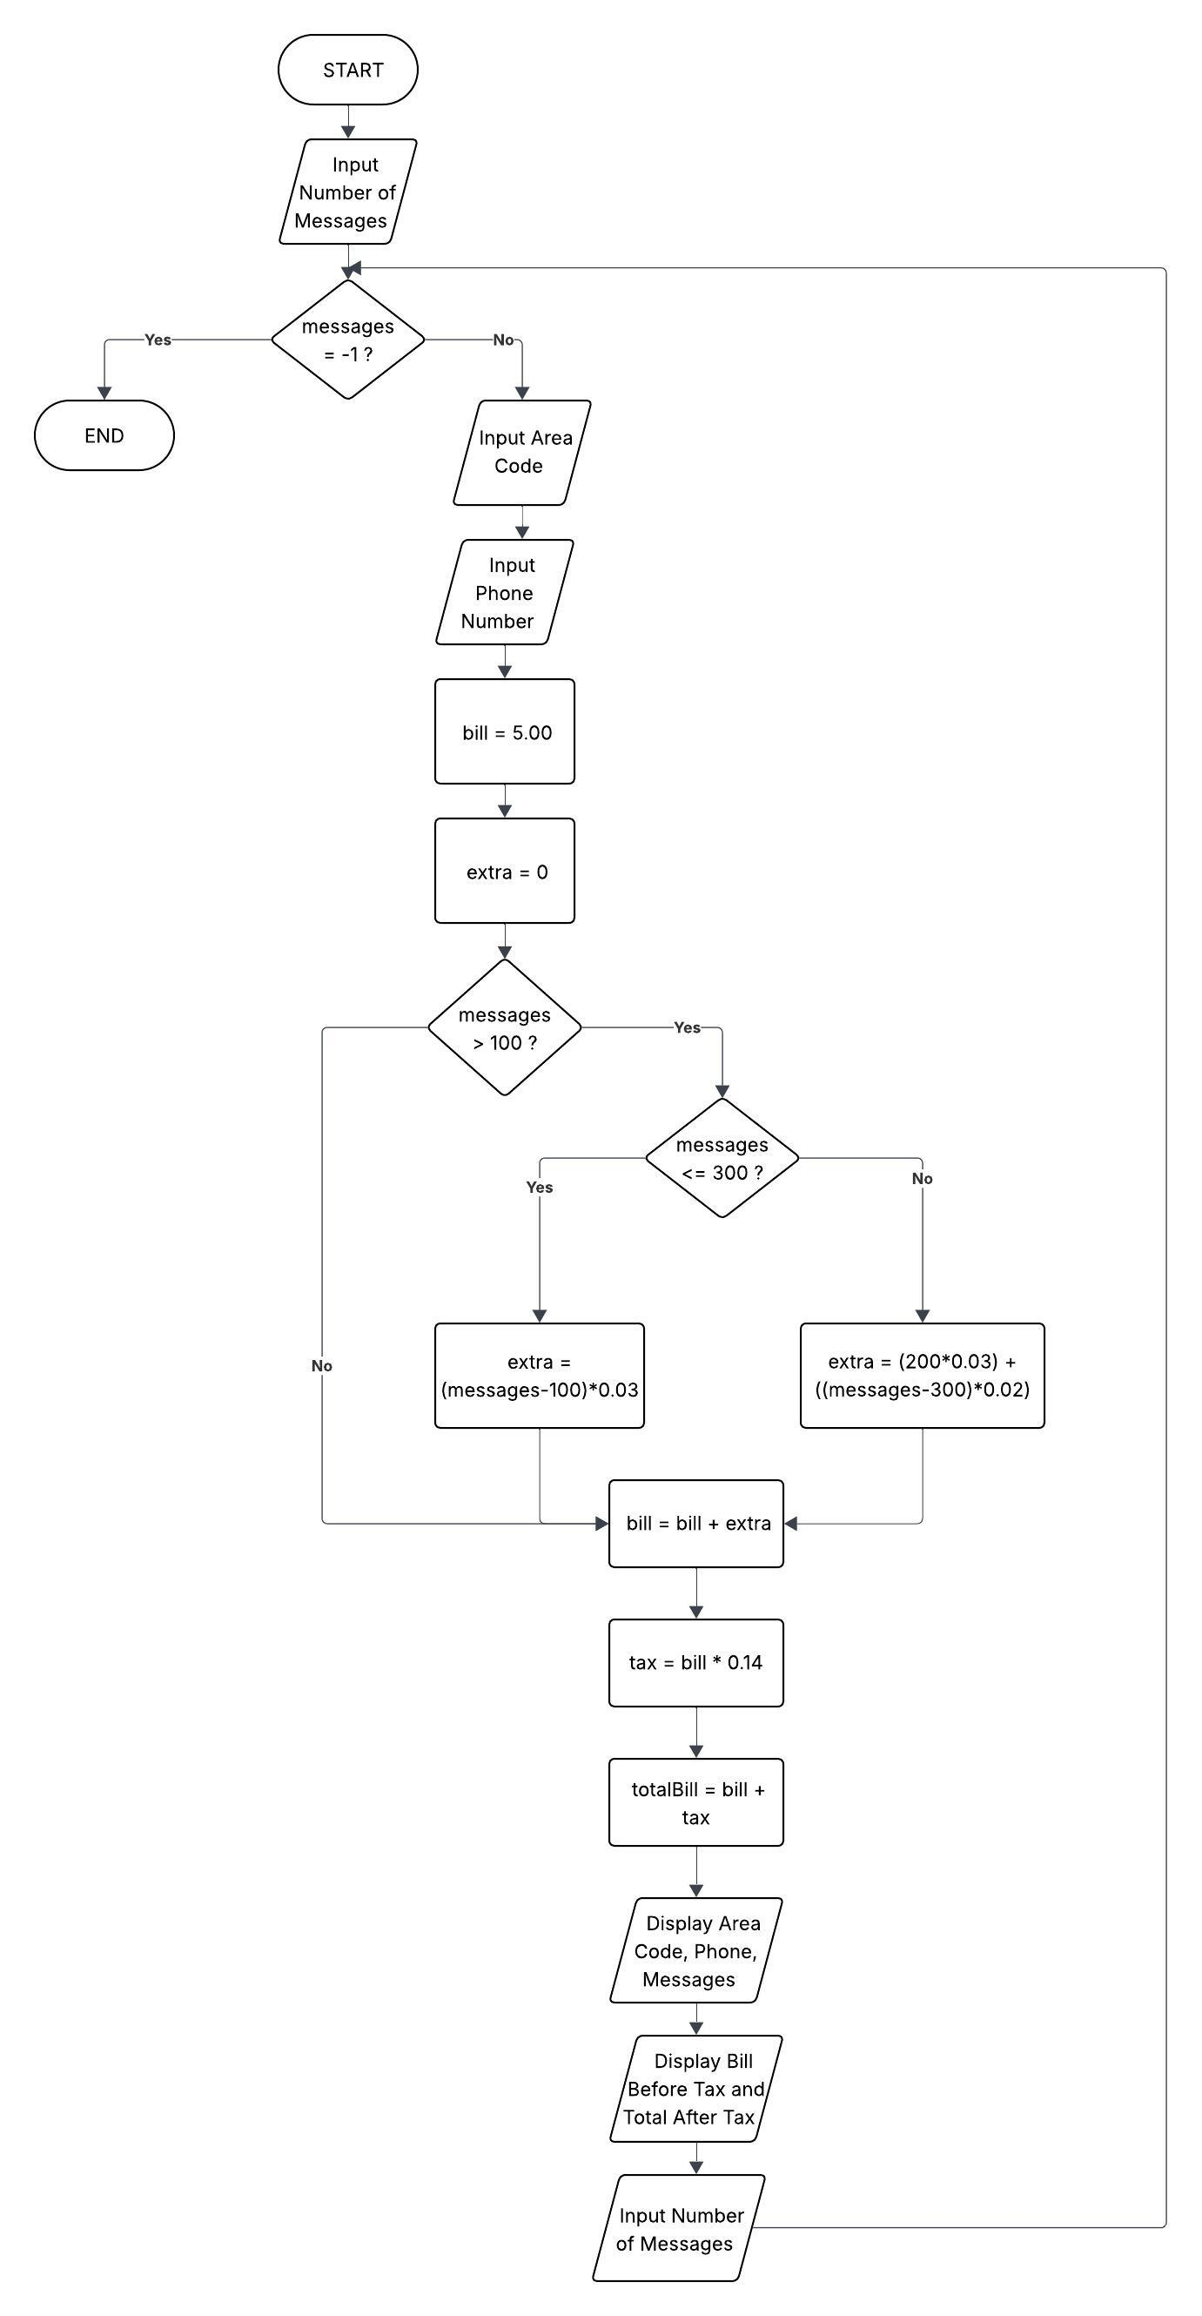
(6C) A program that continually accepts data about text messages until a sentinel value is entered and displays details only about customers who send more than 100 text messages.
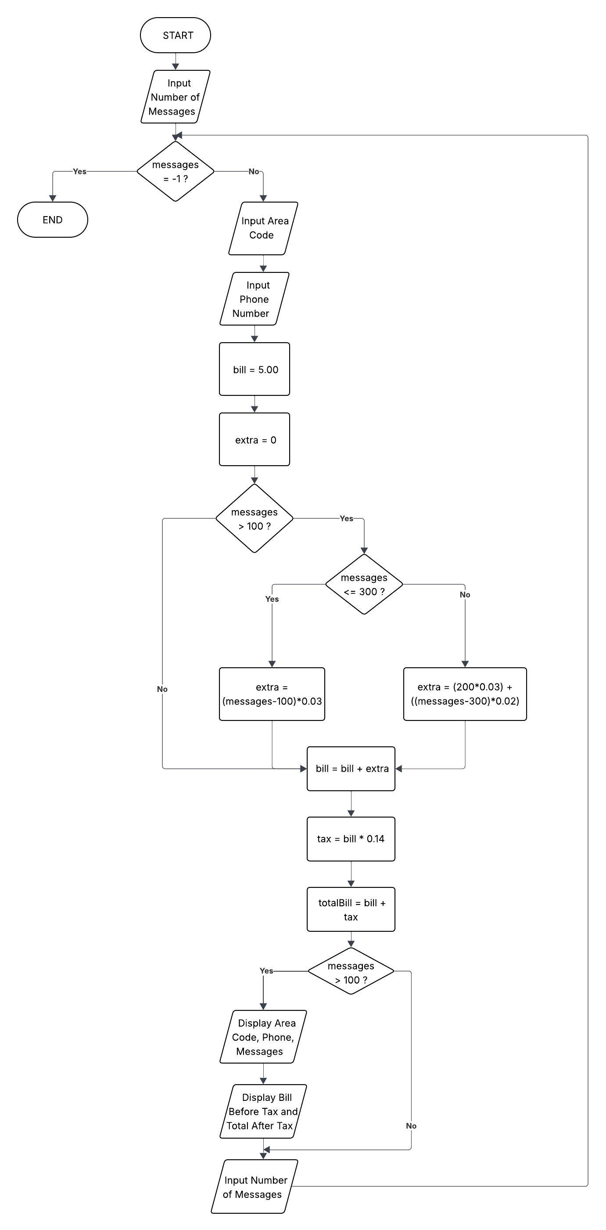
(6d) A program that continually accepts data about text messages until a sentinel value is entered and displays details only about customers whose total bill with taxes is over $10.
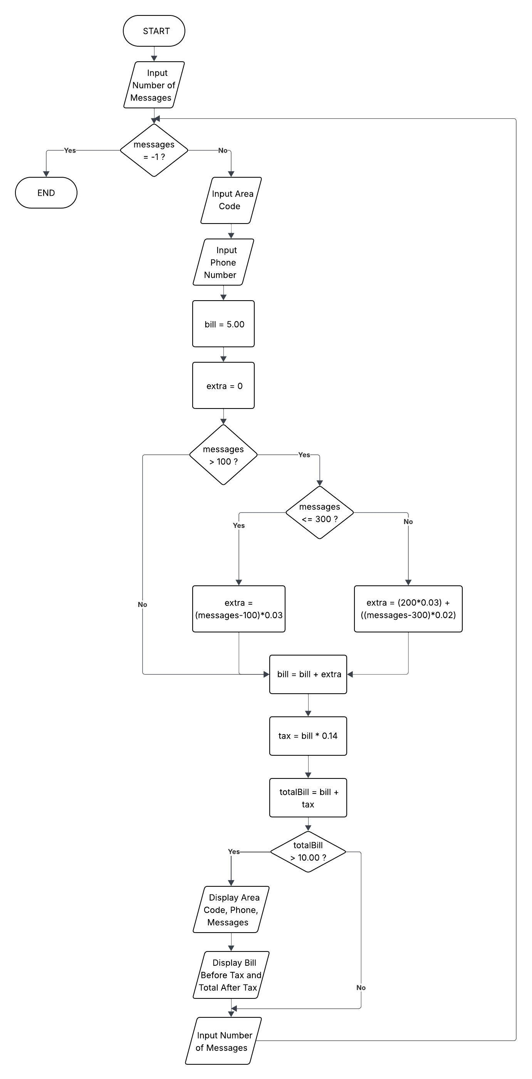
(6e) A program that prompts the user for a three-digit area code from which to select bills. Then the program continually accepts text message data until a sentinel value is entered and displays data only for messages sent from the specified area code.
